Place Matters:
Mapping Community Loss as a New Social Indicator

The Community Loss Index (CLI): A New Social Indicator

Place Matters:
CLI recognizes the role of “place” as an aggregator of individual experiences.
Helps us to understand what happens when large numbers of people living in close proximity regularly suffer multiple, persist losses at the same time.

Unpacking Poverty

Why are health and social problems concentrated in some but not other neighborhoods?
1. The Behavior of the Residents
vs.
2. High Poverty Rates in Poor Neighborhoods
But what about poverty leads people to harm themselves or others? ( our definition of social problems)
What is the pathway between adverse neighborhood conditions and the spatial concentration of health and social problems?

Stress as a Pathway
Well Known: Exposure to severe loss can create health and social problems for individuals.
Less Well Known: What happens to communities in which large numbers of people living in close proximity regularly suffer multiple resource losses at the same time.
The CLI Corrective: Aggregates individual experiences, and helps to understand why heath and social problem amasses in certain areas.

The Community Loss Index
I. Loss or Removal of Household Members due to
Foster care placement
Incarceration
Long-term hospitalization
Untimely deaths (e.g., murders, suicides, and accidents)
II. Loss of Financial Assets due to
Unemployment (job loss)
Foreclosure ( loss of housing)
ALL six losses (a) tend to be unpredictable and uncontrollable and thus (b) appear at the high end of the stress spectrum.

Citywide: Accumulated Community Loss

The sum of
- Foster care placements
- Incarcerations
- Long term hospitalizations
- Untimely Deaths
- Foreclosures
- Unemployment
----------------------
Red= high loss area
Yellow=medium loss area
Green=low loss area

Citywide:
Distribution of Losses

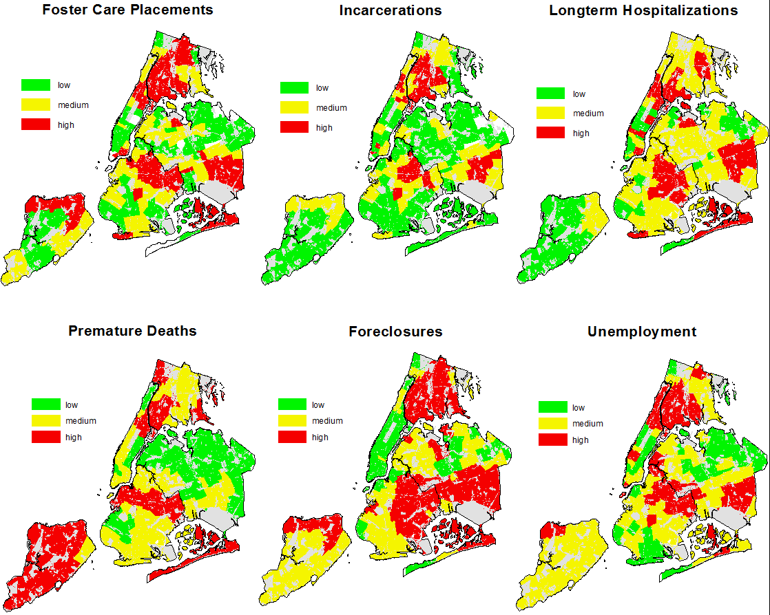

Figure 1: Citywide
Low Loss (A) vs. High Loss Areas( B)

Figure 2
Low Loss (A) vs. High Loss (B) Neighborhoods

People in Place
Low Loss (A) vs. High Loss (B) Ar
A
B
Figure 5: People in Place
Low Loss (A) vs. High Loss (B) Neighborhoods

Application of CLI
Effectively captures a previously unrecognized component of community life and poverty.
Disrupts the view of poverty as a uniform experience.
Can help communities and public officials to:
Unpack poverty in the context of place
Understand how community loss varies by geography & demographics (place & persons)
Work together to fine-tune intervention for change based on actual community needs..

