**Place Matters:**  
Mapping Community Loss as a New Social Indicator

**The Community Loss Index (CLI): A New Social Indicator**

Place Matters:   
  
CLI recognizes the role of “place” as an aggregator of individual experiences.   
  
Helps us to understand what happens when large numbers of people living in close proximity regularly suffer multiple, persist losses at the same time.

**Unpacking Poverty**

Why are health and social problems concentrated in some but not other neighborhoods?   
  
 1. The Behavior of the Residents  
 vs.   
 2. High Poverty Rates in Poor Neighborhoods   
   
But what about poverty leads people to harm themselves or others? ( our definition of social problems)

What is the pathway between adverse neighborhood conditions and the spatial concentration of health and social problems?

**Stress as a Pathway**

*Well Known:* Exposure to severe loss can create health and social problems for individuals*.  
  
Less Well Known:* What happens to communities in which large numbers of people living in close proximity regularly suffer multiple resource losses at the same time.  
  
*The CLI Corrective*: Aggregates individual experiences, and helps to understand why heath and social problem amasses in certain areas.

**The Community Loss Index**

I. Loss or Removal of Household Members due to

*Foster care placement  
Incarceration  
Long-term hospitalization  
Untimely deaths (e.g., murders, suicides, and accidents)*

II. Loss of Financial Assets due to  
  
 *Unemployment (job loss)  
 Foreclosure ( loss of housing)   
  
ALL* six losses (a) tend to be unpredictable and uncontrollable and thus (b) appear at the high end of the stress spectrum.

**Citywide: Accumulated Community Loss**

*The sum of*

* *Foster care placements*
* *Incarcerations*
* *Long term hospitalizations*
* *Untimely Deaths*
* *Foreclosures*
* *Unemployment  
  ----------------------*

*Red= high loss area  
  
Yellow=medium loss area   
  
Green=low loss area*

Citywide:   
Distribution of Losses

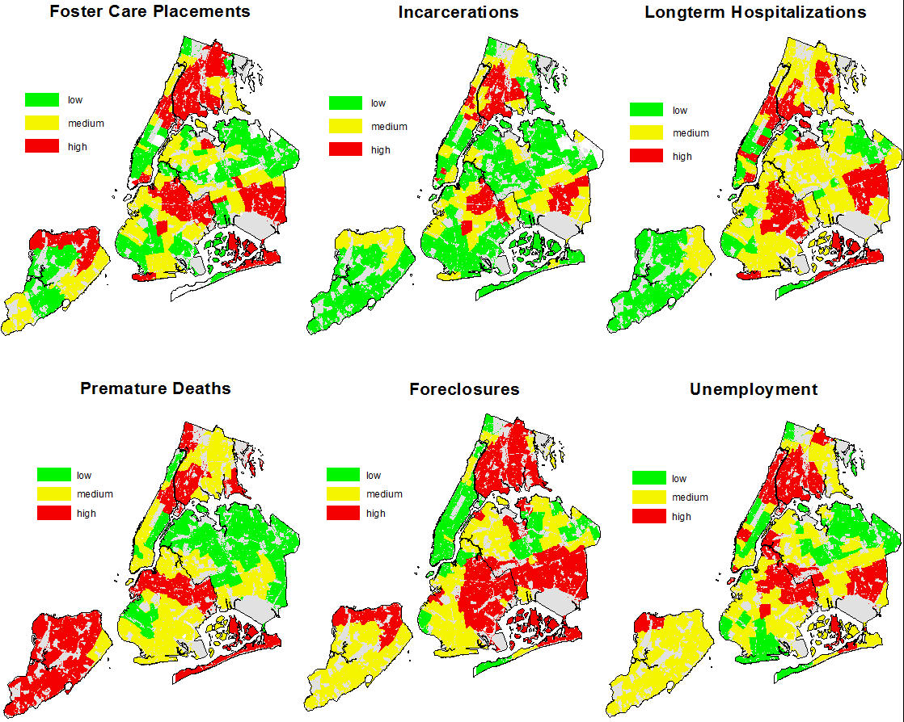

**Figure 1: Citywide  
Low Loss (A) vs. High Loss Areas( B)**

 

**Figure 2  
Low Loss (A) vs. High Loss (B) Neighborhoods**





**People in Place  
Low Loss (A) vs. High Loss (B) Ar**



**A**

**B**

**Figure 5: People in Place  
Low Loss (A) vs. High Loss (B) Neighborhoods**

 

**Application of CLI**

Effectively captures a previously unrecognized component of community life and poverty.   
   
Disrupts the view of poverty as a uniform experience.   
   
Can help communities and public officials to:  
   
 Unpack poverty in the context of place

Understand how community loss varies by geography & demographics (place & persons)  
   
Work together to fine-tune intervention for change based on actual community needs..