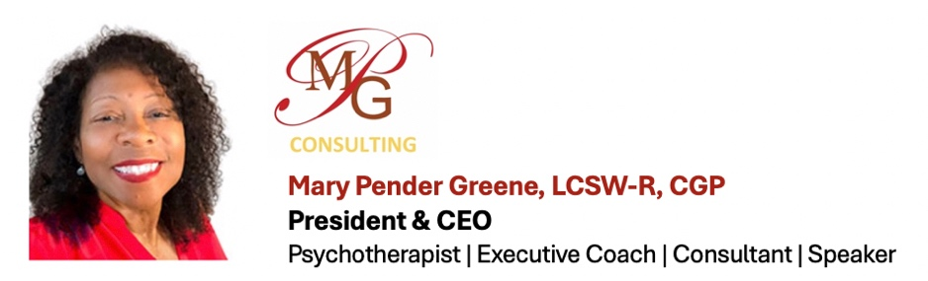

PROFESSIONAL EXPERIENCE
Mary Pender Greene, LCSW-R, CGP is a career/executive coach, organizational consultant, keynote speaker, and a psychotherapist with a private practice. Mary is a thought leader recognized by her peers for her wisdom, contributions, and novel ideas on leadership, professional development, and transforming organizational culture. Through coaching and consultation, she acts as a thought partner with decision-makers to develop and enhance the leadership style of executives and senior leaders from small, mid-size, and large social service organizations in order to best serve their clients and achieve their mission, vision, and values. For over twenty years, she has guided countless leaders in the social services industry to become changemakers in their own right.

Mary is the President & CEO of MPG Consulting (MPGC), a consulting group that is committed to assisting organizations foster a welcoming and respectful work atmosphere that supports all individuals in the pursuit of their maximum potential and in achieving the utmost benefits for their clients. While MPGC specializes in supporting senior management and executive leaders, the coaches, consultants, and trainers also provide professional development to individuals at all levels of an organization. The multiracial team of 90+ consultants is composed of social workers, business experts, educators, restorative justice practitioners, attorneys, mediators, psychologists, psychiatrists, researchers, and community organizers.

MPGC SERVICES
- Recruitment, Attracting the Best Talent
- Retention & Developing a Solid Pipeline
- De-Biasing the Hiring Process & Hiring Best Practices
- Team Building
- Enhancing Relationships & Improving Employee Engagement
- Organizational and Board Assessment
- Strategic Planning
- Board and Staff Retreats
- Executive, Professional, and Leadership Development
- Coaching (Individual & Group) for Staff, Supervisors, Managers & Executives
- 360 Evaluations
- Trainings
- Creating a Welcoming, Supportive and Respectful Workspace
- Supervision Across Difference
- Working Across Generations & Bridging Generational Gaps
- Conflict Resolution & Difficult Conversations

Mary’s background includes serving as the Assistant Executive Director and Chief of Social Work Services at the Jewish Board of Family and Children’s Services, America’s largest non-sectarian mental health and social service organization, as well as serving as President of the National Association of Social Workers, NYC. She is the author of Creative Mentorship and Career-Building Strategies: How to Build Your Virtual Personal Board of Directors, and author of many chapters and articles around organizational and leadership development.

The New York State Education Department recognizes MPG Consulting as an approved provider of continuing education credits for: LCSWs, LMSWs, LCATs, LMHCs, LMFTs, Psychologists, and Psychoanalysts. MPGC is certified in New York State and New York City as an M/WBE.

PARTIAL CLIENT LIST – CONSULTING & TRAINING
ADP | Advocates for Children | Bergen Family Center | Brooklyn Children’s Theatre | Barrier-Free Living| Bureau of Environmental Disease and Injury Prevention | Bronxworks | Brooklyn Defenders Services | Callen-Lorde Community Health Center | Care for the Homeless | CASA-NYC | Center for Family Representation | Celebrate the Beat | Center for Court Innovation | Center for Family Support | Center for Urban Community Services Children’s Museum of Manhattan | Citizens Crime Commission of New York City | City Harvest | Columbia Health |Columbia Psychiatry Department Women's Faculty Group | Cooperman College Scholars | Community Resource Exchange | Counseling In Schools | Edwin Gould Services for Children & Families | Engagewell IPA | Human Resources Administration | Hyde Leadership Charter School| Family Services/Hudson Valley | JobPath | JP Morgan Chase | Felicity House | GMHC | Life Camp, Inc. | Legal Services NYC | Metropolitan Council on Jewish Poverty | Montefiore Bronx Health Collective | Montefiore Health System | Morris Heights Health Center | National Dance Institute | NYC Cure Violence | New York City Defender Services | NYC Department of the Aging | NYC Dept. of Health & Mental Hygiene | NYC Mission Society | SNUG Project NYC Mission Society | NYS Psychiatric Institute (NYSPI) | NYU McSilver Institute | PR Society of America | Race Forward |Rosie’s Theater Kids | Safe Horizon | Sanctuary for Families | SBU | SCO Family of Services | SSEU Local 371 | The Health and Housing Consortium | The Bedford-Central Presbyterian Church | The Black Psychiatrists of Greater New York | Children's Village | The Concord Baptist Church of Christ | The Hub | The Institute for Family Health | The Jewish Board of Family and Children's Services (JBFCS) |The NYC Administration for Children's Services | The Summit Center | TROIKA Entertainment | YWCA of the City of New York | Vera Institute | Vibrant Emotional Health | Villa of Hope

KEYNOTE TOPICS
- Thriving through Adversity
- How to Build Your Virtual Personal Board
- The Value of Having Multiple Mentors
- Leaving a Legacy – Fortifying Yourself for the Journey
- Effective Leadership -Leading with Heart
- Preparing to Lead
- Women in Leadership Series
- Knowing When It’s Time to Move On: Exiting with Grace
- Re-Wiring Not Retiring: Preparing for the Next Phase
- Mental Health & the Clergy

HONORS & AWARDS
- NASW Top Leader Award
- National Network for Social Work Managers’ Organizational Excellence Award
- New York University Silver School of Social Work – First Annual Distinguished Alumni Award
- Human Services Council Leadership Award
- The Network Journal 25 Most Influential Black Women in Business

ORGANIZATIONS
- Former President National Association of Social Workers, NYC
- Founding Member of The Anti-Racist Alliance
- Inaugural Board Member The McSilver Institute for Poverty Policy and Research at NYU Silver School of Social Work
- Founding Member of National Registry of Certified Group Psychotherapists (AGPA)
- American Association of Sexuality Educators, Counselors and Therapists (AASECT)
- The Society of Sex Therapy and Research (SSTAR)
- Member of The New York State Education Social Work Board
- Past Member/Board of Trustees, The Hudson Guild & Assoc. for Advancement of Social Work w/Groups
- Executive Committee of Black Agency Executives

CERTIFICATIONS & ADVANCED TRAINING
- William Alanson White Institute, The Organization Certificate Program
- American Group Psychotherapy Association, Certified Group Psychotherapist
- S.U.N.Y Science Center at Brooklyn/The Family Therapy Institute, Post-Graduate Training and Certification in Family Therapy
- Ackerman Institute, Sex Therapy Training
- The Gottman Institute, Couples Therapy Training Courses
- A.K. Rice Institute, courses in Organizational Development and Group Dynamics
- Tavistock Institute, Leicester England, Training Organizational Development and Group Dynamics
- National Association of Black Social Workers, African Centered Social Work Practice Certificate
- Peoples’ Institute: Undoing Racism Training, Understanding Institutional Racism

EDUCATION
Master of Science in Social Work
New York University School of Social Work

Bachelor of Science in Pre-Social Work
New York University

